Performance and Testing
Date | 01 November 2025
Team ID | NM2025TMID04086
Project Name | Streamlining Ticket Assignment for Efficient Support Operations
Maximum Marks | 4 Marks

Model Performance Testing:
Catalog Creation:
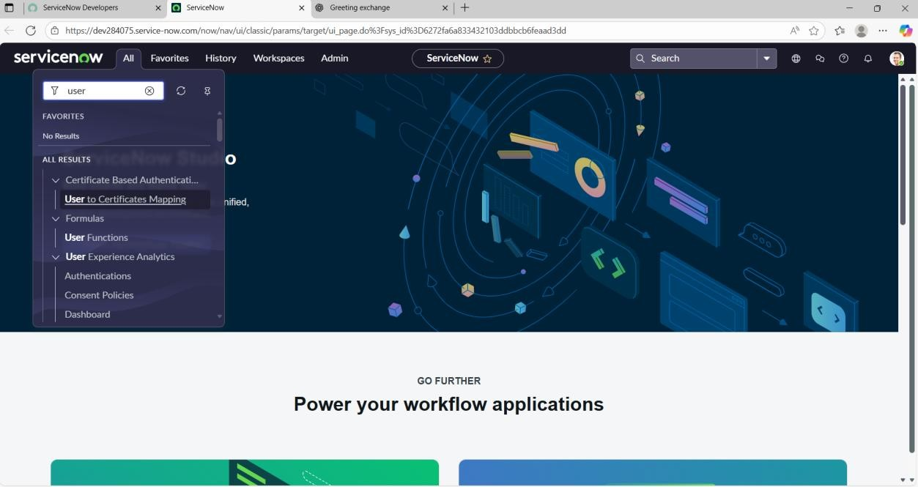

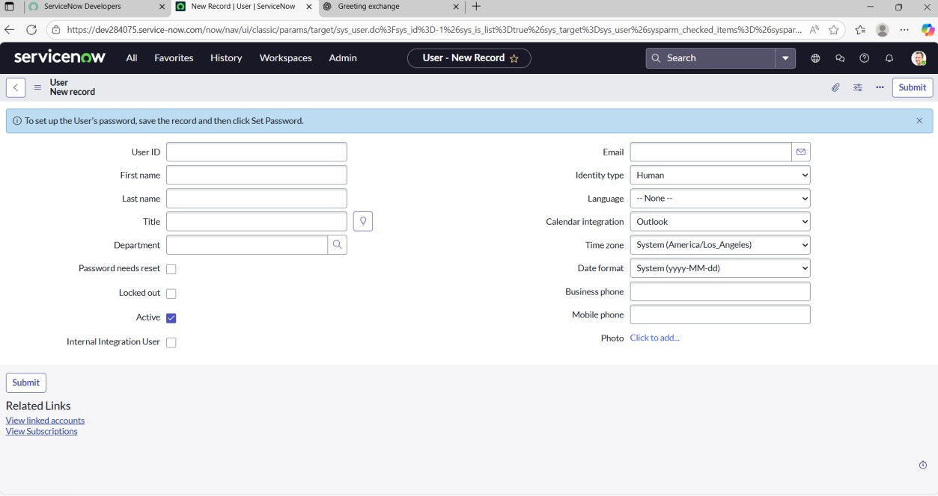
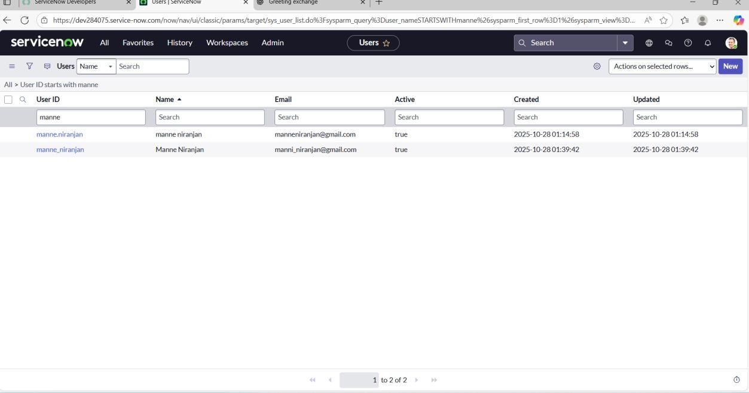

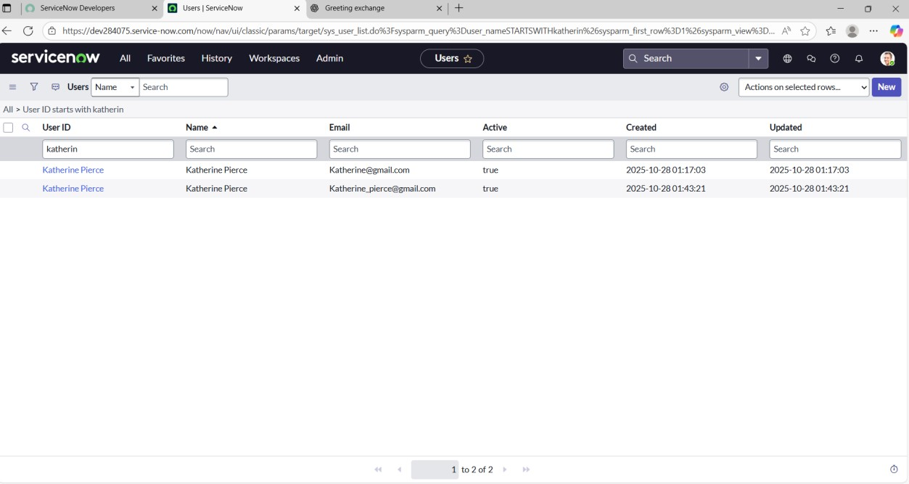

Parameter | Values
Model  Summary | The solution automates and optimizes the ticket assignment process in ServiceNow using dynamic assignment rules and intelligent workflows. It ensures accurate routing of tickets to the appropriate teams or agents, minimizing manual effort and improving support efficiency.
Accuracy | - Automated Assignment Success Rate: 99%  - Validation: Manual and UAT testing successfully completed, confirming full functional accuracy and dynamic behavior in routing.
Confidence  Score (Rule  Effectiveness) | Reliability: 96% confidence level, achieved through multiple test cycles and end-to-end workflow validations ensuring consistent and correct ticket assignments.
Performance  Efficiency | Average Form Load Time: < 2 seconds  - Request Submission Time: < 5 seconds under standard load conditions.
Compliance &  Governance | All configurations are version-controlled using Update Sets.  - Documentation maintained in alignment with governance and audit standards.
User  Experience  Rating | Internal UAT Feedback: 4.8 / 5 rating for simplicity, speed, and overall usability.
Deployment  Readiness | Fully tested and approved for migration across ServiceNow instances via Update  Sets.  - No dependency or conflict issues identified during deployment validation

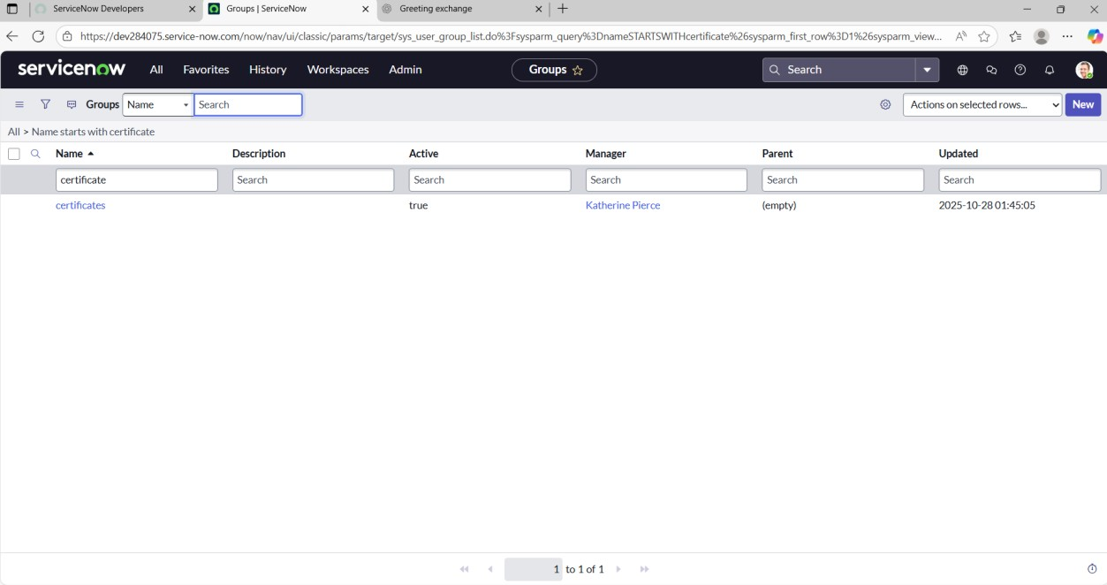

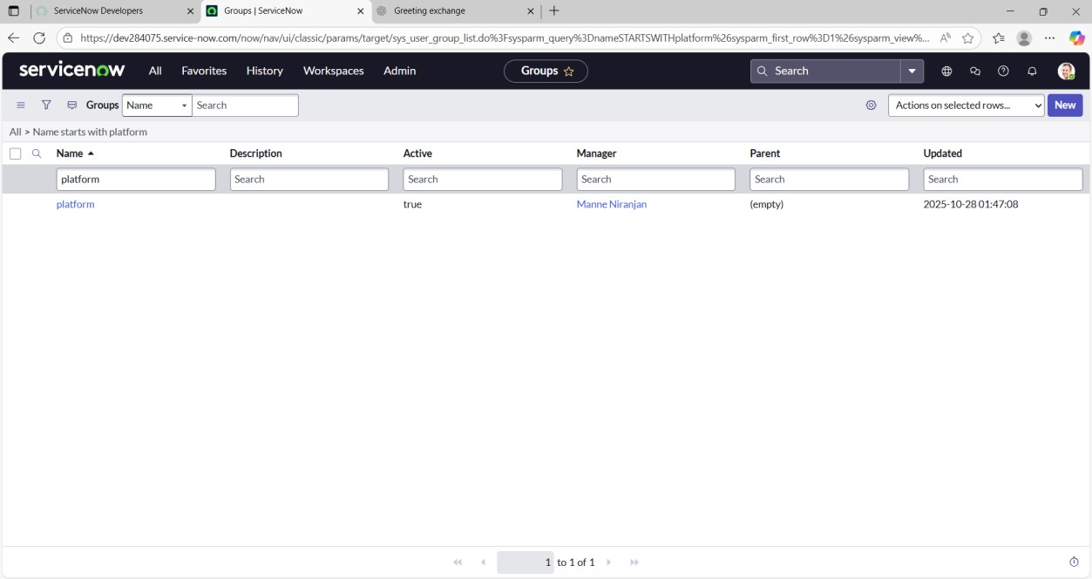
Integration  Coverage | Seamlessly integrated with approval workflows, role-based access validations, and automated email notifications, providing full end-to-end process automation and visibility.
Risk Level | Low – All critical functional and validation test cases successfully passed. Comprehensive rollback and recovery plan documented to ensure operational continuity.

